**Test Report**

**(SoulCure)**

**Test Case 1**

**Code**

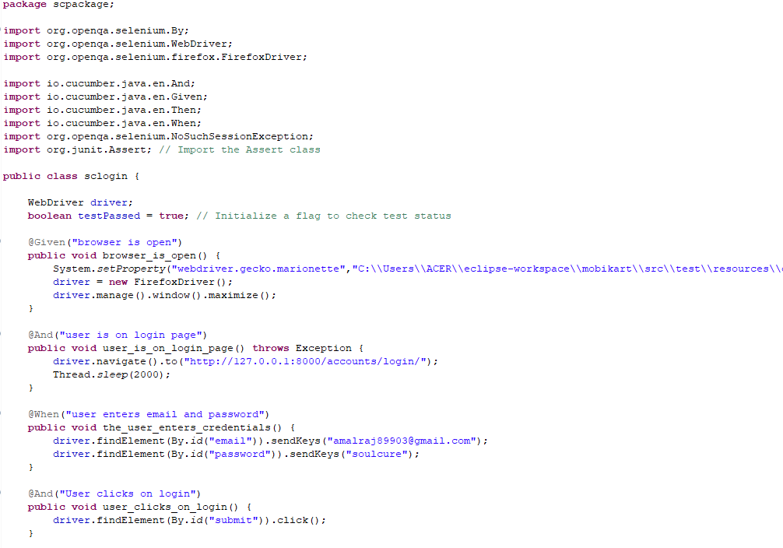

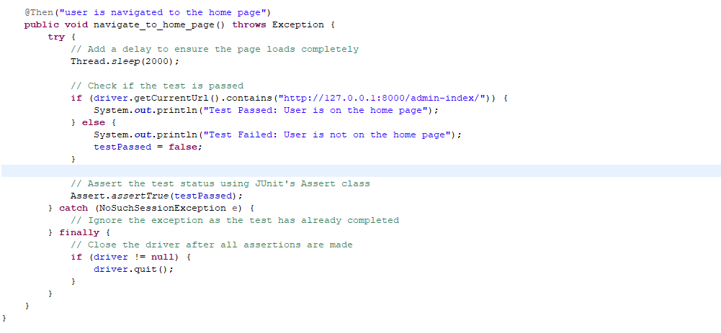

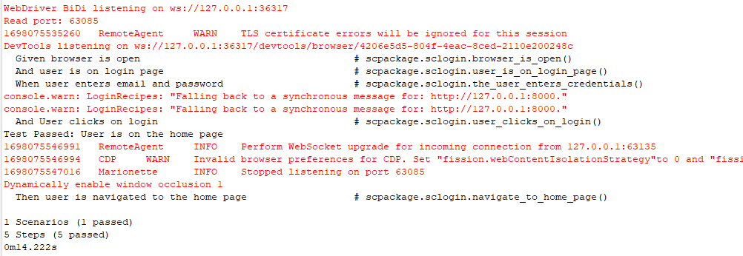**Output:**

**Test Report**

|  |  |  |  |  |  |
| --- | --- | --- | --- | --- | --- |
| **Project Name : SoulCure** | | | | | |
| **Login Test Case** | | | | | |
| **Test Case ID:** 1 | | | **Test Designed By: Amal Raj** | | |
| **Test Priority**  **(Low/Medium/High):** High | | | **Test Designed Date: 23**-10-2023 | | |
| **Module Name**: Login Page | | | **Test Executed By: Ms. Lisha Varghese** | | |
| **Test Title:** Verify login with valid email and password | | | **Test Execution Date: 23**-10-2023 | | |
| **Description:** Test the Login Page | | |  | | |
| **Pre-Condition:** User has valid email id and password | | | | | |
| **Step** | **Test Step** | **Test Data** | **Expected Result** | **Actual Result** | **Status(Pass/Fail**  **)** |
| 1 | Navigation to Login Page |  | Login Page should be displayed | Login page displayed | Pass |
| 2 | Provide Valid email | User  Name: amalraj89903@g mail.com | User should be able to Login | User Logged in and navigated to the dashboard with records | Pass |
| 3 | Provide  Valid  Password | Password:  soulcure |
| 4 | Click on Sign In button |  |
| **Post-Condition:** User is validated with database and successfully login into account. The Account session details are logged in database | | | | | |

**Test Case 2:**

**Code**

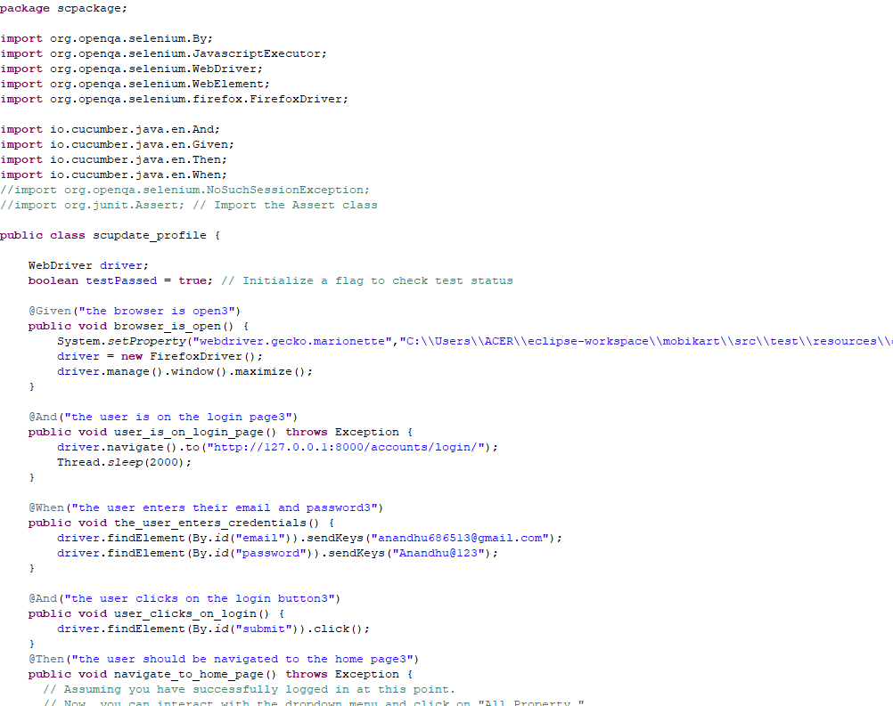

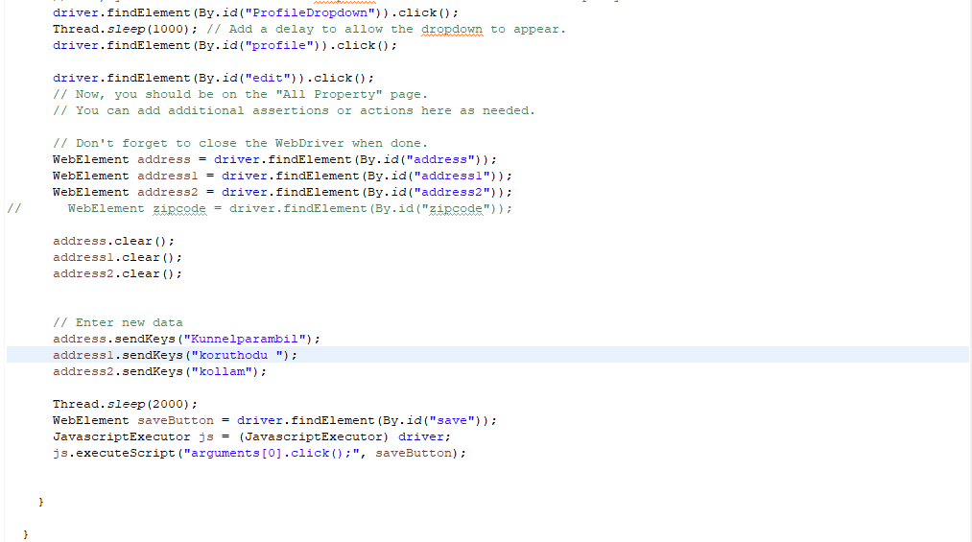

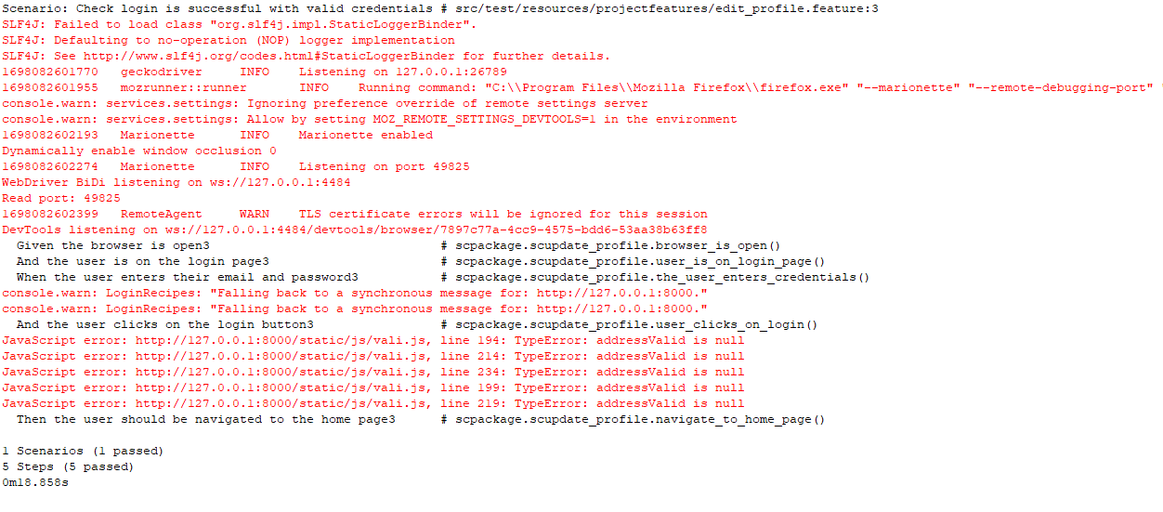**Output**

**Test report**

|  |  |  |  |  |  |
| --- | --- | --- | --- | --- | --- |
| **Project Name : SoulCure** | | | | | |
| **Profile Update Test Case** | | | | | |
| **Test Case ID:** 4 | | | **Test Designed By: Amal Raj** | | |
| **Test Priority**  **(Low/Medium/High):** High | | | **Test Designed Date: 23-**10-2023 | | |
| **Module Name**: Update profile | | | **Test Executed By: Ms. Lisha Varghese** | | |
| **Test Title:** Verify update profile | | | **Test Execution Date: 23-**10-2023 | | |
| **Description:** Testing the update profile page | | |  | | |
| **Pre-Condition:** Require valid profile fields and update button | | | | | |
| **Step** | **Test Step** | **Test Data** | **Expected Result** | **Actual Result** | **Status(Pass/Fail**  **)** |
| 1 | Navigation  to profile Page |  | Profile page should be displayed | Profile page displayed | Pass |
| 2 | Provide  Address line1 | kunnelparambil | User should be able to update profile | Profile updated and message should be displayed. | Pass |
| 3 | Provide  Address line2 | Korthudu po |
| 4 | Provide  Address line3 | kollam |
| 4 | Click on save button |  |
| **Post-Condition:** User is inserted into the database and successfully registered. Profile details updated and inserted successfully into database. | | | | | |

**Test Case 3:**

**Code**

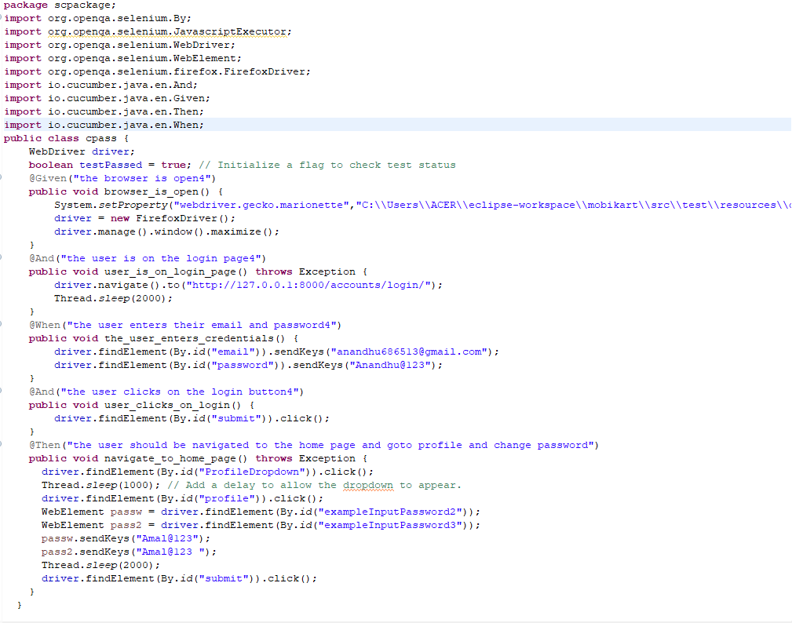

**Output:**

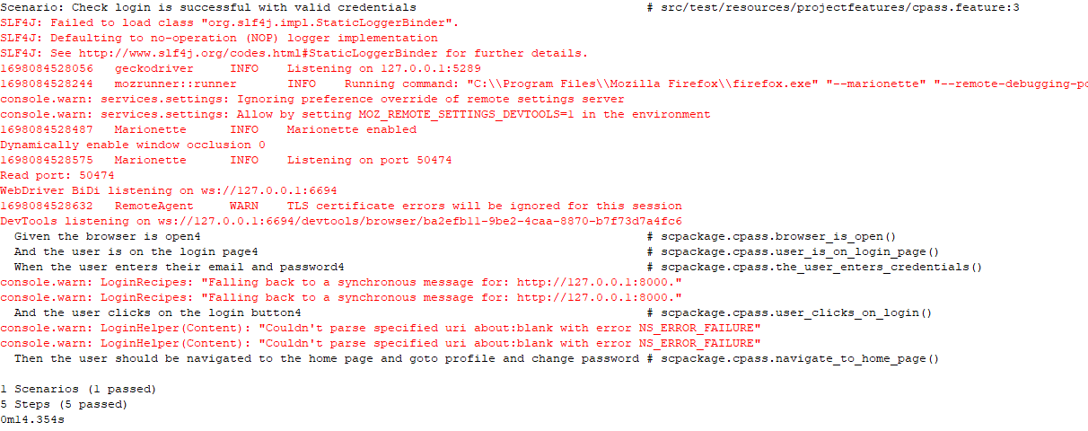

**Test Report**

|  |  |  |  |  |  |
| --- | --- | --- | --- | --- | --- |
| **Project Name : SoulCure** | | | | | |
| **Change Password Test Case** | | | | | |
| **Test Case ID: 5** | | | **Test Designed By: Amal Raj** | | |
| **Test Priority**  **(Low/Medium/High):** High | | | **Test Designed Date: 23**-10-2023 | | |
| **Module Name**: Change password | | | **Test Executed By: Ms. Lisha Varghese** | | |
| **Test Title:** Verify change passwsord | | | **Test Execution Date: 23**-10-2023 | | |
| **Description:** Testing change password | | |  | | |
| **Pre-Condition:** Require valid password | | | | | |
| **Step** | **Test Step** | **Test Data** | **Expected Result** | **Actual Result** | **Status(Pass/Fail**  **)** |
| 1 | Navigation to change  password page |  | Profile page should be displayed | Profile page displayed | Pass |
| 2 | Provide old password | Nandhu@123 | User should be able click add on change password button | Password should be changed. | Pass |
| 4 | Provide new password | Anandhu@123 |
| 5 | Provide confirm password | Anandhu@123 | User should not be able click button | Password should not be changed. | Pass |
| 7 | Click on Change password button |  |
| **Post-Condition:**  Password Change and inserted successfully into database | | | | | |

**Test Case 4:**

**Code**

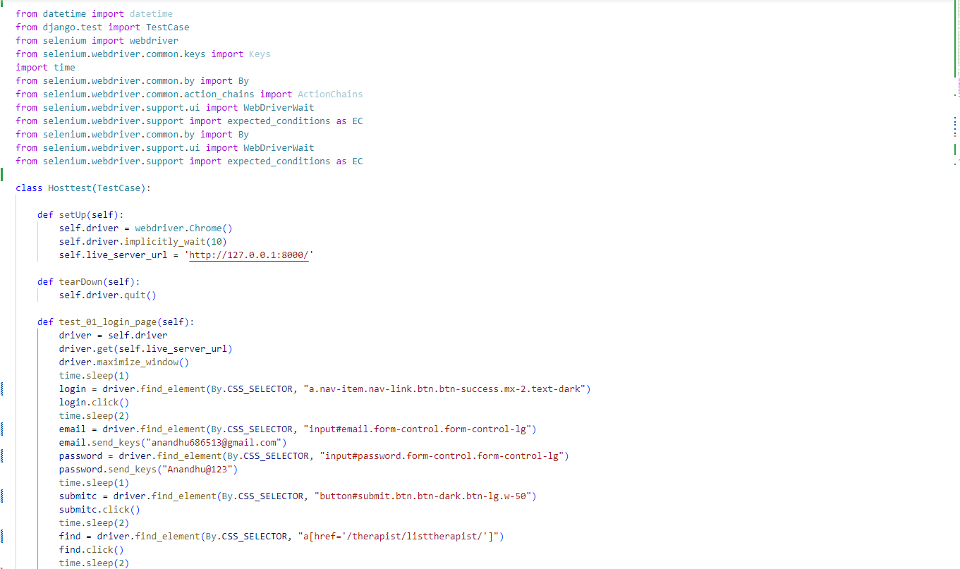

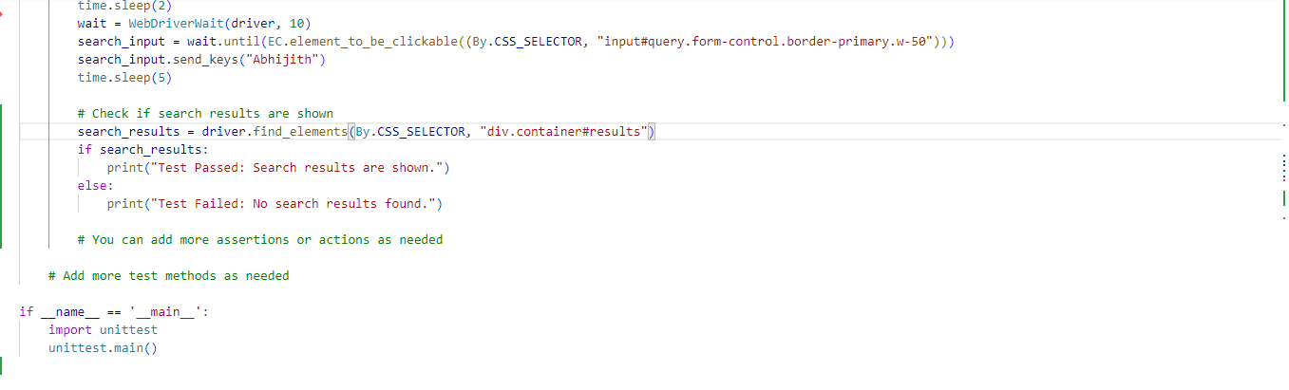

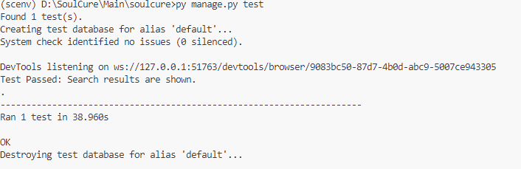**Output:**

**Test Report:**

|  |  |  |  |  |  |
| --- | --- | --- | --- | --- | --- |
| **Project Name : SoulCure** | | | | | |
| **Change Password Test Case** | | | | | |
| **Test Case ID: 5** | | | **Test Designed By: Amal Raj** | | |
| **Test Priority**  **(Low/Medium/High):** High | | | **Test Designed Date:** 23-10-2023 | | |
| **Module Name**: Search | | | **Test Executed By: Ms. Lisha Varghese** | | |
| **Test Title:** Verify Search Function | | | **Test Execution Date:** 23-10-2023 | | |
| **Description:** Testing Search Function | | |  | | |
| **Pre-Condition:** Require valid Search data | | | | | |
| **Step** | **Test Step** | **Test Data** | **Expected Result** | **Actual Result** | **Status(Pass/Fail**  **)** |
| 1 | Navigation to home page |  | Nav bar should shown  with search bar | Nav bar shown with search bar | Pass |
| 2 | Provide query to be searched | Abhijith | User should be able input in search bar | User was able input in search bar and search results are shown | Pass |
| 3 | Results are shown |  |
| **Post-Condition:** Results for query are shown in the page | | | | | |